COMPTIA A+ CORE 1

# CONTENTS

* Introduction
* Cable Types
* Motherboards
* Cooling and Power
* System Memory
* BIOS/UEFI
* Storage Devices
* Virtualization Concepts
* Cloud Computing
* Networking Basics
* Wireless Networks
* Internet Connections
* Network Addressing and Communication
* Network Configurations
* Network Servers and Services
* Laptops and Mobile Devices
* Mobile Applications
* Laptop Hardware
* Printers and MFDs
* Printer Types
* Troubleshooting Methodology
* Troubleshooting Hardware Issues
* Troubleshooting Storage Devices
* Troubleshooting Networks
* Troubleshooting Mobile Devices
* Troubleshooting Print Devices
* Conclusion.

Lectures: 218

Video: 26 total hours

Instructor: Jason Dion (Udemy)

# INTRODUCTION

* This is an entry level course and requires no experience
* the test expects knowledge equivalent to 9 to 12 months of hands on experience ont the field
* this course would help you build the hands on experience on your own ahome
* There are 5 Domains and 27 Objectives.

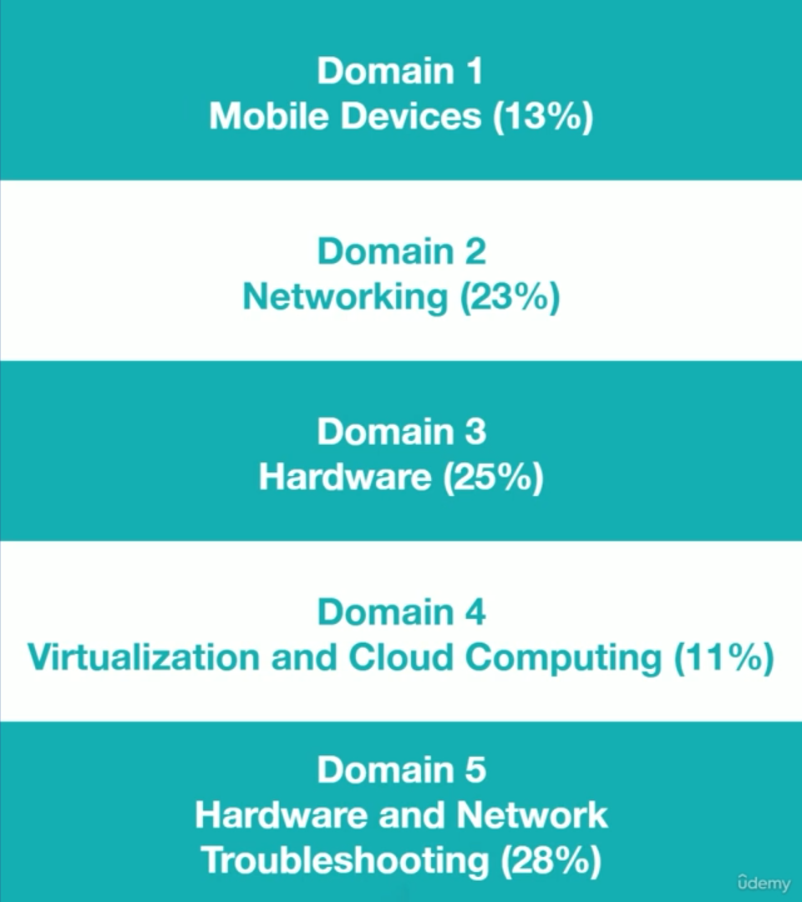

* We aren’t covering these domains in the same order as given by comptia, but a more logical order optimal for learning.

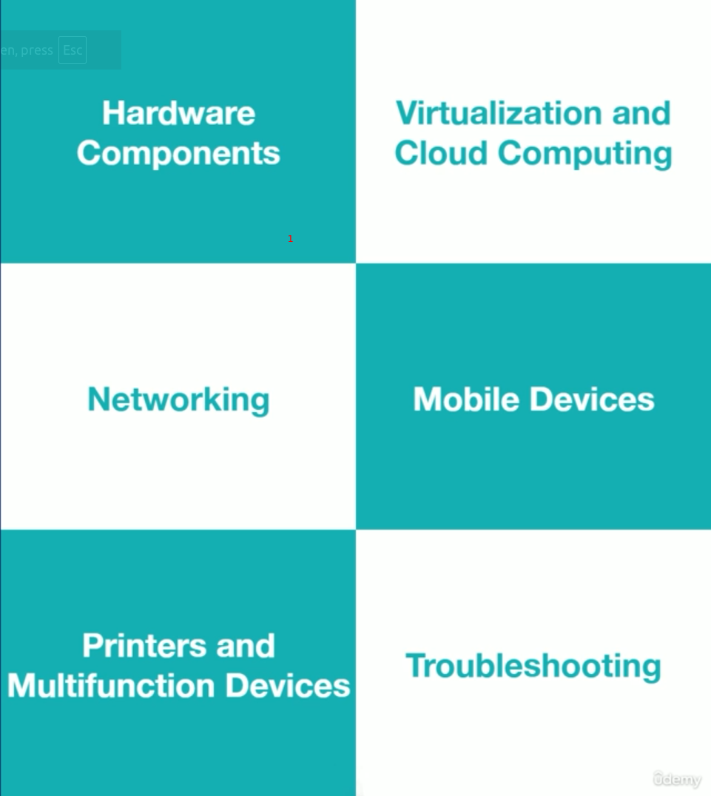

* at the beginning of each section, the domain and associative objectives to be covered are stated
* the lessons in this course are going to build on each other
* always take core 1 and core 2 from the same version
* it is recommended not to take core 1 and core 2 at the same time
* the exam has an official textbook
* read the exam objectives
* read the recommended study plan by jason dion
* use the study guide so you don’t have to make bulk notes